9th October 2005

Mr. D. E. Pule
Director General
BotswanaPost
Poso House
Khama Crescent
Plot no. 8841
Gaborone

Dear Mr Pule,

In recent weeks I have become aware that Botswana Post has broken ranks with the other former PSL customers and may now even intend to drop Corvus all together. I find it surprising that you should stop using the installed system for the sake of a few errors.

If work started today, you could have a fully functioning Counters system, Pensions system, Money Orders system and P.O. Box system operating with a year. In the first six months, the data collected from your network could feed directly into your accounts system and you could have management reports to support an expanding client base and new marketing activities.

Your customers and clients would immediately see the benefits and start to view BotswanaPost as a high tech supplier and provider. You could then go onto tackle domestic track and trace, integration with IPS, IFS and Western Union. You would be able to share Money order information directly with IFS countries as well as South Africa Post and Namibia Post and could start to operate your own international electronic money order system with all the revenues going to BotswanaPost. It would be easy for you to quickly provide services for new clients and supply electronic information back to them on a daily basis.

I don’t know the reasons for the delay, or even the change of direction, but I believe it would be a serious miscalculation to start again and lose out on the benefits the current system would provide BotswanaPost if a few problems were corrected.

When we met in London, you indicated to me that you would like me to come to Botswana. Since then, I have created a company called Cykor Systems and have been waiting, ready to come to Botswana and complete the promise made to you by PSL.

I would be delighted to hear your current plans and if I am to continue with Cykor Systems. If there is anything I can do to assist you in your endeavours or any information that I could provide to help in the decisions you are making, please don’t hesitate to let me know.

Yours sincerely

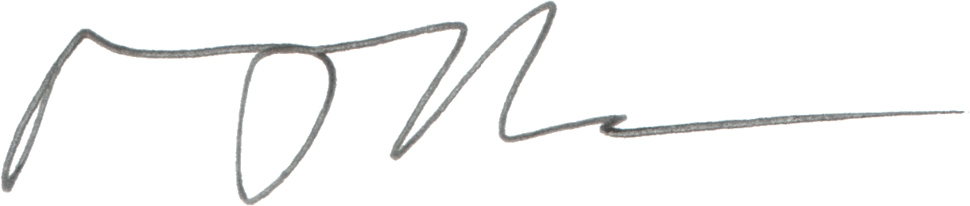

Mark Durbin
Managing Director

